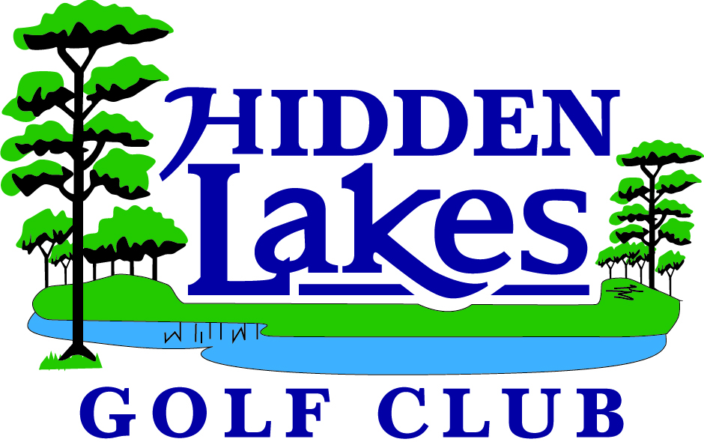
Hidden Lakes Junior Golf Camps
2026 Summer Program

Elementary School & Middle School Junior Golfers:

- Introduce Campers to the Game of Golf in a Fun Manner using our TopTracer Driving Range!
- Introduce the Kids to the Golf Basics.
- Bring the skills learned to the course!

Instructors:
Ian Hoffman, Assistant Golf Professional
Grant Folmsbee, Assistant Golf Professional

Ages 6 - 14

There will be 3 Camps
Circle the ones you would like to participate in.

June 15th-18th July 13th – 16th Aug. 3rd-6th
From 12:00– 3:00 From 12:00 – 3:00 From 12:00 – 3:00
$200 per Child $200 Per Child $200 Per Child

Child’s Name:____________________________ Age:_________ Grade:________

Parent/Guardian’s Name:___________________________

Phone:______________________Alt.Phone:______________________Email:__________________

I certify that my child is in good health and may participate in golf activities. I will not hold anyone connected with Hidden Lakes Golf Club (HLGC) responsible in the event of an accident or injury as a result of his/her participation, nor will anyone connected with HLGC be responsible for medical, dental or other expenses incurred as a result of injuries sustained during activities. I agree that any pictures, videos or other media may be taken during the activities is the exclusive property of HLGC and may be used at its discretion.

Parent Signature:_________________________________ Date:___________________

For More Information Contact:
Ian Hoffman, Hidden Lakes Golf Club
Phone: 386.427.4138
Proshop@HiddenLakesGolfClub.com

